Use Case – Document

Module Name: View Claims

Use Case Name: View Claims Details

**ID: 207**

**Name: View Claims**

**Title:**

**Description:**

Customer should be able to see list of claims submitted by him.

**Use Case Diagram:**

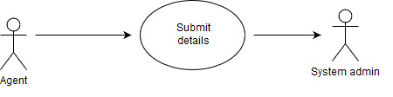

**Pre-Conditions:**

1. Customer should have claim for at least one policy.

1.1 Irrespective of direct buying policy or through agent.

**Post-Conditions:**

If the use case is successful

1. Customer will be able to view list of claims.

If not, customer will get notification message.

**Primary Flow:**

The use case starts when the customer chooses to view list of claims submitted by him

* 1. Customer clicks on view claim button.
  2. Customer views all the claims submiited by him.
  3. Use case ends.

**Alternate Flow:**

1. Customer is not able to view list of claims

1.1 If the customer is not able to view the list of claims then he has not submitted

Claim request or he hasn’t claimed any insurance policy.

**Data:**

|  |  |  |
| --- | --- | --- |
| Sr. No. | Data | Datatype |
| 1 | Policy Number | NUMBER(10) |
| 2 | Policy type | VARCHAR(20) |
| 3 | Claim Date | DATE |
| 4 | Claim Approved | VARCHAR2(10) |

**Screen Shots:**